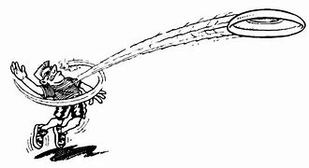
Ultimate Invitation
Sir Winston Churchill Secondary School will be hosting an Ultimate Frisbee Tournament
Attention: Physical Education Heads and Ultimate Frisbee coaches
When: Friday April. 28, 2023
Time: Game 1 starts 8:30am (finish time will depend on the number of teams registered)
Where: Sir Winston Churchill School
Cost: $60.00 Space is limited. Cheques payable to Sir Winston Churchill School
Teams: Co-ed 7 on 7 (4 / 3 split on field - alternates gender ratio see NRHSAA regulations)
Spirit of the Game: Teams are encouraged to come with ready to play hard but with an attitude to have fun.
After the game, each team should be prepared to have a little “Spirit” fun

It is important that players are familiar with the rules as ultimate is a self-officiated sport.
Rules: 11th edition rules: http://www3.upa.org/ultimate/rules/11th_links
10 Simple Rules: http://www3.upa.org/ultimate/rules/10simplerules
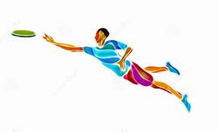
Contact: Tammy Short at tammy.short@dsbn.org to take a spot.
